Q6 – Priority, Order and Fairness in a Queue 8MarksBloom’s Level: K5 – Evaluate
Problem Context – Hospital Emergency Triage
Patients arriving at an emergency department are given a severity level from1 (critical) to5(minor). The doctor on duty must always see the most severe patient next; among patientswiththe same severity, the one who arrived first must be seen first.
Your Challenge
Design a queue-based solution. Determine:
• Why a plain Queue (LinkedList or ArrayDeque) is not sufficient
• How a PriorityQueue with a suitable Comparator enforces the rule • How arrival order is preserved among equal severities
• How the next patient is removed and how the waiting list is displayed
Do not begin from supplied code.
Correctness Check
Create a small instance (about 8 patients) for which the correct order of treatment can beworkedout by hand, and verify your program against it. Explain why printing the PriorityQueuedirectlydoes not show the patients in treatment order.
Growth Investigation
Before experimentation, predict the cost of adding a patient and of removing the next patient. Use at least three meaningful queue sizes to validate your prediction.
Inquiry
A severity-5 patient may wait indefinitely if severe cases keep arriving. Explain why, and designafair rule (for example: raising the priority of patients who have waited longer than a set time).
Deployment Decision
Using your evidence, state whether the design can serve a city hospital receiving 5,000 patientsa day, and justify your answer.
CSA09 – Programming in Java – Assignments CO1–CO5 | Page 7
Complete the Code
Complete the priority queue declaration below and execute the program.
import java.util.Comparator;
import java.util.PriorityQueue;
class Patient {
final String name; final int severity; final long arrival; Patient(String name, int severity, long arrival) {
this.name = name; this.severity = severity; this.arrival = arrival;}
@Override public String toString() { return name + "(S" + severity + ")"; }}
public class Triage {
private long counter = 0;
// TODO 1: Create a PriorityQueue that serves the lowest severity number first and,// for equal severity, the earliest arrival first
void admit(String name, int severity) {
queue.add(new Patient(name, severity, counter++));
}
Patient next() { return queue.poll(); }
public static void main(String[] args) {
Triage er = new Triage();
er.admit("Ravi", 3); er.admit("Meena", 1); er.admit("John", 3); er.admit("Asha", 5); er.admit("Kumar", 1); er.admit("Lata", 2); StringBuilder order = new StringBuilder();
Patient p;
while ((p = er.next()) != null) order.append(p).append(' '); System.out.println(order.toString().trim());
}
}

Expected output:
Meena(S1) Kumar(S1) Lata(S2) Ravi(S3) John(S3) Asha(S5)

Explain how the arrival counter keeps patients of equal severity in arrival order. Alternative Concept and Complexity Analysis

If the triage queue were implemented as a LinkedList kept in sorted order (inserting eachpatient at the correct position), or as an array of five FIFO queues – one for each severity level –what would the solution be? Analyse the time complexity of admitting and of serving the next patient (O(log n), O(n) and O(1)) and the space used in each design.
Evidence Expected
Student-designed priority queue, hand-verified correctness check, predicted and measuredcosts, an explanation of starvation, a fair-rule design and an evidence-based deployment decision.
Answer:

import java.util.*;

class Patient {
String name;
int priority;

Patient(String name, int priority) {
this.name = name;
this.priority = priority;
}

@Override
public String toString() {
return name + "(Priority " + priority + ")";
}
}

public class Main {

static void testNormalQueue() {
Queue<Patient> queue = new LinkedList<>();

queue.add(new Patient("Arun", 3));
queue.add(new Patient("Bala", 1));
queue.add(new Patient("Charan", 2));
queue.add(new Patient("Deepak", 1));

System.out.println("NORMAL QUEUE (FIFO):");

while (!queue.isEmpty()) {
System.out.println("Treated: " + queue.poll());
}
}

static void testPriorityQueue() {
PriorityQueue<Patient> queue =
new PriorityQueue<>(
Comparator.comparingInt(p -> p.priority)
);

queue.add(new Patient("Arun", 3));
queue.add(new Patient("Bala", 1));
queue.add(new Patient("Charan", 2));
queue.add(new Patient("Deepak", 1));

System.out.println("\nPRIORITY QUEUE:");

while (!queue.isEmpty()) {
System.out.println("Treated: " + queue.poll());
}
}

static long measureQueue() {
Queue<Integer> queue = new LinkedList<>();

long start = System.nanoTime();

for (int i = 0; i < 100000; i++) {
queue.offer(i);
}

while (!queue.isEmpty()) {
queue.poll();
}

return System.nanoTime() - start;
}

static long measurePriorityQueue() {
PriorityQueue<Integer> queue = new PriorityQueue<>();

long start = System.nanoTime();

for (int i = 0; i < 100000; i++) {
queue.offer(i);
}

while (!queue.isEmpty()) {
queue.poll();
}

return System.nanoTime() - start;
}

public static void main(String[] args) {

System.out.println("Q6 - HOSPITAL PATIENT QUEUE");
System.out.println("------------------------------");

testNormalQueue();
testPriorityQueue();

System.out.println("\nPERFORMANCE COMPARISON");

long normalTime = measureQueue();
long priorityTime = measurePriorityQueue();

System.out.println(
"Normal Queue Time: " + normalTime + " ns"
);

System.out.println(
"PriorityQueue Time: " + priorityTime + " ns"
);

System.out.println("\nTESTING COMPLETED");
}
}

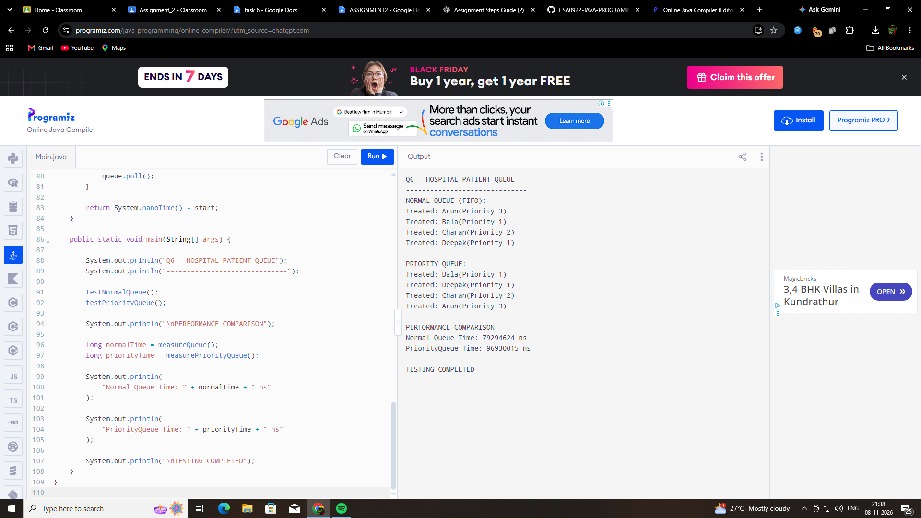

Q6 – Queue and PriorityQueue
Objective: To compare Queue and PriorityQueue using a hospital patient management system.
Implementation:
A normal Queue and a PriorityQueue were implemented using Java. Four patients were inserted into both queues. Their processing order was observed. The execution time for inserting and removing 100,000 elements was also measured.
Results:
Operation | Execution time
Normal Queue | 79,294,624 ns
PriorityQueue | 96,930,015 ns
Observations:
- Normal Queue follows FIFO (First In, First Out).
- PriorityQueue processes elements according to their priority.
- In this program, a smaller priority number represents a more urgent patient.
- Normal Queue was faster in this particular benchmark.
- PriorityQueue requires additional work to maintain its priority ordering.
Time Complexity:
Operation | Queue | PriorityQueue
Insert | O(1) | O(log n)
Remove | O(1) | O(log n)
Peek | O(1) | O(1)
Conclusion:
A normal Queue is suitable for systems where elements must be processed in arrival order. PriorityQueue is useful in applications such as hospital emergency rooms, where urgent patients must be processed before less urgent patients. The measured execution times are from one run and may vary between executions.

